LIVERPOOL COUNCIL

PROPOSED DOUBLE BRICK VENEER DWELLING

IN RESPECT OF
LOT 71, WHITSUNDAY CIRCUIT NORTH KELLYVILLE
DP: 286769

FOR
MR & MRS HUMPHREYS C/O WISDOM HOMES

STATEMENT OF ENVIRONMENTAL EFFECTS



17-19 Central Hills Drive Gregory Hills NSW 2557
Phone: 1300 855 775 Fax: 02 4647 1233

INTRODUCTION
This document comprises a Statement of Environmental Effects to accompany a Development Application to undertake the construction of a double storey brick veneer dwelling & swimming pool.

SITE & SURROUNDING LOCALITY

The subject site is bounded by a frontage to Whitsunday Circuit of 1,523 metres, an Western boundary of 2,615 metres, and a Eastern boundary of 1,885 metres and an Southern (rear) boundary of 18.290 metres comprising a total area of 433.13m².

The locality is a newly developed residential site which will be maintained for the proposed development.
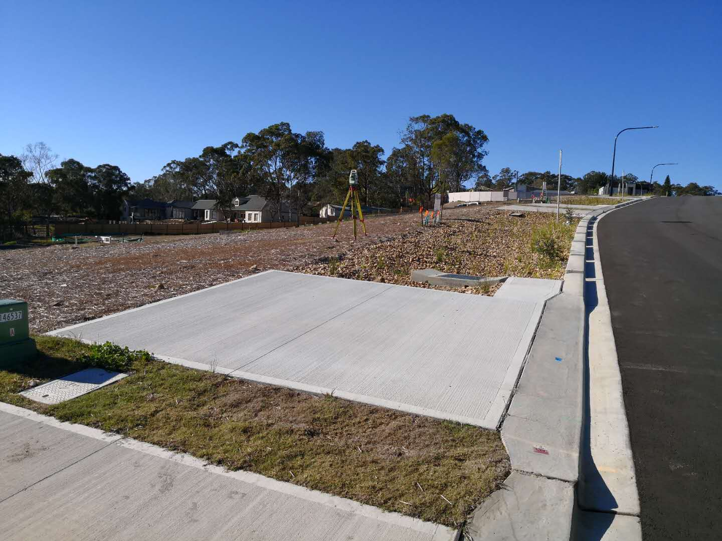
DESIGN GUIDELINES (DCP)
The proposal is for a double storey brick veneer dwelling with selected Colourbond roof. The proposed residence will have a front setback of 4,5 metres, and a rear setback of 1,885 metres. The side setbacks of the proposed development will be a minimum of 11,523mm to the East side and 2,615mm to the West side of the property.

The proposed dwelling will consist of:
- Garage
- 4 Bedrooms (inclusive of Master Suite with Ensuite)
- Kitchen
- Leisure Area
- Dining Area
- Main Bathroom
- Laundry
- Powder Room
- Outdoor Leisure
- Home Office
- Home Theatre
- Upper Lounge

The floor area for the main dwelling is:
- Ground Floor = 171.30m²
- First Floor Living = 165.83m²
- Porch = 10.97m²
- Garage = 34.04m²
- Outdoor Leisure = 19.40m²

The total floor area for the proposed dwelling, including Garage, Porch & Outdoor Leisure = 433.13m².

The proposed residence will be a Wisdom Homes Manhattan 44 Ens – a design which will be adapted to the future surroundings and character in the Chipping Norton area.

The home is designed with style and character through the use of articulation to the external walls as well as variations to the roof, with the design minimizing the bulk and scale of our proposed development.

The overall appearance of our proposal is in keeping with The Hills Shire Council DCP _________ - Objectives and Development Control.

IMPACTS OF THE DEVELOPMENT
The proposal has no social or economic impact to the locality. Given the quality of the design the dwelling and proposed landscaping will have minimal impact on the existing streetscape other than to enhance the vision of the community.

The slab on ground construction will result in minimal disturbance to the natural slope of the subject land. Stormwater will be conveyed to the proposed rainwater tank located to the Northern side of the proposed dwelling with the overflow discharged to the street, in which satisfies Council’s requirements.

COMPLIANCE WITH DEVELOPMENT STANDARDS
The premises is situated in an area zoned Residential (2) under The hills shire City Council’s LEP. The construction of a dwelling is permissible in this zoning, with Council’s consent.
Compliance with the relevant DCP is summarized in the following table:-
Issue | Council | Proposed | Comment
 | Requirements
Front Setback (m) | 4.5m (min) | 4.5m | Complies
Side Setback (m) | 900mm | 1500mm RHS  1500mm LHS | Complies
Rear Setback (m) | G.F. 4m  F.F. 6m | 20775mm  25023mm | Complies
Car Space | 2 accessible spaces | Double garage | Complies
Site Coverage | 50% (ground)  30% (first) | 27.44%  22.16% | Complies
Cut & Fill | Cut: 500mm  Fill: 500mm | CUT: 1620mm  FILL: 285mm | Non-compliance
Stormwater  Disposal | To RWT, overflow to rear existing easement | To water tank. O/flow  to rear via rain garden | Complies
Driveway Grade | Max 22% | 2% | Complies
Landscape Area | Min 30% of site | 58.04% | Complies
Private Open Space | Min: 80m² | 339.57m² | Complies

ECOLOGICAL SUSTAINABLE DEVELOPMENT
The proposal demonstrates cross flow ventilation throughout the dwelling.

Wall insulation to the value of R2.0 and ceiling insulation to the value of R3.5 has been included in this design to warm the house in winter and cool the house in summer.

It is proposed to install a 3000L above ground rainwater tank connected to all toilets and outdoor taps. This complies with the requirement of of the NSW BASIX policy and all targets relating to water, energy and thermal comfort are achieved.

CONCLUSION
The proposed dwelling is of consistent standards to The Hills Shire Council DCP requirements and its planning principles to best suit the site and the future surrounding properties.

